**Law Firm Information Management System**

**LUNODZO MWINUKA**

**BSc. ITS**

**Supervisor: Mr. Frank Kilima**

**A Project Report submitted to Department of Computing Science Studies in partial fulfilment of the requirements for the award of Bachelor Degree of Science in Information Technology and Systems (ITS) of Mzumbe University.**

**2017**

# DECLARATION

I, the undersigned, do here by declare that the work contained in this project report entitled **“Law Firm Information Management System”** is my own. This report contains no material that has been submitted previously, in whole or part, for the award of academic degree or diploma. All sources that I have used or quoted have been indicated and acknowledged by means of complete references and paraphrasing.

Signed: …………………………………… Date: ……………………………….

# CERTIFICATION

We, the undersigned, certify that we have read and hereby recommend for acceptance by the Mzumbe University, a project report entitled “**Law Firm Information Management System”** in a partial fulfillment of the requirements for awards of the degree of Bachelor of Science in Information Technology and Systems.

Major Supervisor Name: ………………………………………………………………….

Major Supervisor Signature Date

____________________________ __________________________

Internal Examiner Name: …………………………………………………………………

Internal Examiner Signature Date

____________________________ __________________________

# ACKNOWLEDGEMENTS

I can remember all the late-night sleeps that I have been facing during development of the System and I remember to have taken a lot of efforts in this project. However, it would not have been possible without the kind support and help of many individuals from Mzumbe University and BLS Attorneys.

I would love to thank my Project Supervisor, Mr. Frank Kilima who stood by my side during each step of this project. His patient guidance, encouragement and constant supervision are one of those cheerful moments of System development. I have learnt a lot.

It is with no doubt that without primary information from Mr. Mgeta I would have moved the very wrong way towards development of the **Law Firm Information Management System**. I remember to have been directed to meet the Tanganyika Law Society (TLS) for prior information and thanks, from there I had a lot to learn. I’m not forgetting his suggestion to develop the same idea of the system basing in Court operations, this remains as the debt in my Career.

I would like to express my **special gratitude** towards my brother, Edrick Mwinuka (on going Law School Student, 2017) who was temporary working at BLS Attorneys. He was the base for system’s requirements elicitation. I would have not made it perfect without his guidance.

The challenges and willingness to support from my Colleagues, Tito Magoti, Joseph Prosper, Emmanuel Mwakasege, Witness Jasper, Lawrance Massanja, Ntonsite Mwamlima, Gift Matemba, Loyani Kisula who have dedicated their abilities, have made it possible to complete my Project. Thank you guys.

I would not forget the courage I had from Students’ Helpdesk Unit (SHU) members, my roommates and Mackrina Rwiza. They both made me take steps with strength and belief to success.

# ABBREVIATIONS

BLS Best Legal Services

CSS Cascading Style Sheet

ER Entity Relationship

HTML HyperText Markup Language

JS JavaScript

JSP Java Server Pages

MU Mzumbe University

SQL Structured Query Language

TLS Tanganyika Law Society

UI User Interface

# ABSTRACT

Imagine of losing a Criminal Case which is about to commence at the Court with full Witnesses side and all required evidences only because of losing Case Files from the Court, Law Firm or an Attorney, the Case which is actually waiting for execution of Judges to let the Criminal Face Justice.

Tanzanian Law Firms are facing challenges on enhancing their operation and maintaining interaction between Lawyers and Clients, Case processing being marked as the leading challenge towards success of their Cases. Clients and Lawyer feels insecure with confidentiality of their Case files and personal details.

This project aims at developing an interactive web platform for Law Firms which will help Lawyers and Clients access their Cases online but more importantly they should be able to track their Case Progresses.

Today, every operation is being switched to digital, this marks the necessity for Law Firms to transform their mode of operation from analog to digital with help of latest technological platforms.

The Law Firm Information Management System is developed using Java Server Pages (JSP) serving as Server side script and Bootstrap framework serving as the Front end interface.

**TABLE OF CONTENTS**

DECLARATION i

CERTIFICATION ii

ACKNOWLEDGEMENTS iii

ABBREVIATIONS iv

ABSTRACT v

LIST OF FIGURES ix

LIST OF TABLES x

CHAPTER ONE 1

BACKGROUND AND PROBLEM STATEMENT 1

1.1 Background 1

1.2 Problem statement 1

1.3 Research objective and research question 2

1.3.1 General Objective 2

1.3.2 Specific objectives 2

1.4 Significance and scope 3

1.4.1 Significance of the study. 3

1.4.2 Scope of the study 4

1.5 Conclusion 5

CHAPTER TWO 6

LITERATURE REVIEW 6

2.0 Introduction 6

2.1 Topic review 6

2.1.1 Methodology 6

2.1.2 Project Methodology 7

2.2 Domain Review 7

2.2.1 MyCase 7

2.2.2 Law Firm Systems 8

2.2.3 FindLaw 9

2.2.4 Intuit Quickbooks 10

2.3 Problem Conclusion 11

CHAPTER THREE: 12

REQUIREMENTS ELICITATION AND SYSTEM ANALYSIS 12

3.1 Introduction to Requirement Elicitation 12

3.2 Elicitation and classification of requirement 14

3.2.1 User requirements 14

3.2.2 System Requirements 18

3.2.3 Use Case diagram 19

CHAPTER FOUR 21

SYSTEM DESIGN 21

4.1 Introduction to system design 21

4.2 System design implementation 22

4.2.1 Methodological review 22

4.3 Database design 22

4.4 User interface Design 23

4.4.1 Activity diagram 24

4.4.2 Sequence diagram 26

CHAPTER FIVE 28

SYSTEM IMPLEMENTATION 28

5.0 Introduction 28

5.1 Introduction to implementation 28

5.1.1 System assumption: - 28

5.2 Development Tools 29

5.3 Development Platform 31

5.4 Database Management System 31

5.5 Functionalities and services implementation 31

5.7 Back end and database implementation 33

5.8 Front end and User Interface implementation 33

5.9 System testing and evaluation 35

5.9.1 Unit Testing 36

5.9.2 Integration testing 36

CHAPTER SIX 37

CONCLUSION AND RECOMMENDATIONS 37

6.0 Introduction 37

6.1 Achievement of research objectives 37

6.2 Limitation/weakness of the system 37

6.3 Future work 37

6.4 Conclusion and Recommendations 38

REFERENCES 39

# LIST OF FIGURES

Figure 2.1: MyCase Web system 8

Figure 2.2: Law Firm Systems 9

Figure 2.3: FindLaw Web System 10

Figure 2.4: Intuit Quickbooks Web System 10

Figure 4.1: The structure of ER Diagram 23

Figure 4.2: A front interface design of the System 24

Figure 4.3: Activity Diagram 25

Figure 4.4: A Login Sequential Diagram Design 27

Figure 5.1: A front end interface design (Landing page after Login) 34

Figure 5.2: Case Progress 34

Figure 5.3: System's report 35

# LIST OF TABLES

Table 3.2.3: Use Cases Description 20

Table 5.1.1(a): Hardware requirements 29

Table 5.1.1(b): Software requirements 29

# CHAPTER ONE

# BACKGROUND AND PROBLEM STATEMENT

## 1.1 Background

Law Firms as business entities formed by one or more lawyers to engage in the practice of Law has being there since the imposition of the Law on the Earth. Its raise came after realization of the need of the community (in my project to be referred as clients) for Legal support. Clients need awareness on their Legal rights and responsibilities and in some cases to be presented in civil and criminal cases.

Law Firms may also assist their customers in business transactions, Legal agreements, developing and signing contracts and in some case challenging and recommending the best practices of the Law to the Government entities.

Law Firms are basing on partnership, and typically organized around partners who jointly own the Firm and they are business directors of the Legal operation. Associates, who are now becoming the employees of the Firm provide paralegal, clerical and more services.

Virtual Law Firms are also growing in terms of operations around the Globe, a 21st Century development being marked as the source to emergence of Virtual Law Firms, to clarify; these are virtual businesses with virtual business address without any physical block to meet them. They use modern technologies to communicate and operate from remote locations and provide their services around the Globe remotely hence avoiding costs of maintaining physical properties with low overheads comparing to traditional Law Firms (Sue, 2011)

All these forms of Law firms face operational, managerial and organizational challenges in their daily operations. As an experience describes clearly on their mode of operations and the rate of their results.

## 1.2 Problem statement

Law firms are considered to be one of the most important tool in defending human rights with standing orders, unfortunately case processing for their clients has being a very serious challenge due to physical separation difficulties and storage and retrieval challenges. This, has made a remarkable time delay of cases on Courts but also case processing has been delayed in individual Firms, this includes legal support perpetrated by the firm to their Clients.

Law Firms also are experiencing difficulties in records management and file keeping. This may lead in one way or the other to unwise decisions towards law support to clients, due to lack of supportive document in decision making or due to difficulties in allocating supporting Documents. Law Firm managers strive so hard to improve Firm’s efficiency but human errors are inevitable in working environment, this makes the challenges to stay awake in daily operation of Firms.

## 1.3 Research objective and research question

This part will highlight the System objectives, taking into consideration both general and specific objectives.

### 1.3.1 General Objective

Main objective of this project is to design and develop a web based system that will help Firm’s Managers to manage Cases (details and schedules) in Tanzanian Law Firms.

### 1.3.2 Specific objectives

1. To design and develop a user-friendly UI to motivate users (Law Firms) to use the System easily,
2. To design and implement secured and efficient database to store and retrieve information for Law Firms (for easy manipulation of Data),
3. To implement backend by selected server side scripting language to manipulate data in database,
4. To test and validate functionalities of the System.

## Significance and scope

This section explains how the system will be beneficial to all stake holders and users of the system on referencing its main objectives and indicating the limits of the project in the problem domain.

### 1.4.1 Significance of the study.

The Law Firm Information Management System is expected to revolutionize all the Firms’ operations in Tanzania. Stakeholders are expected to experience an easiest way to communicate with their clients. The system marks the following advantages: -

1. To facilitate Digital law practices

The system provides a means by which Firms could interact with their clients in fulfilling their Legal support needs.

1. Avoid physical headquarters disturbances

In late years, no one seems to be interested with the unnecessary crowd of customers in their offices if there exist any other easy ways to serve them. The Law Firm Information Management System let the Law Firms to opt for optimal way of serving their customers online instead of practicing their daily activities in traditional ways.

1. Capture the huge market of people looking for help online

There’s a huge market of people looking for legal assistance online. All these kind of groups could be easily attracted with the Law Firm Information Management System and engage themselves in the Firms with digital Systems.

1. Document Management

The system also provides an easy means for Lawyers and Firms’ manager to save their documents and retrieve them whenever needed. This will make it easier for publishers to track number of their publications but also Clients to view Publications of Lawyers who are leading their cases or providing them with Legal support.

1. Time tracking

Schedule tracking is one of important aspects in any working environment. They system provides users with Schedule management feature for ease tracking of their schedules and event planning.

1. Case progress Tracking

One of the most important aspect of the Law firms is Case processing, considering the fact that, they are the driving force of any Law Firm. The system provides a feature for Lawyers to update case progresses during all the proceedings from the Court, also the system allows at any time users to view and download their case progress.

### 1.4.2 Scope of the study

The project covers the whole process of Clients and Lawyers registration, management of Cases and their progresses depending on the proceedings from the Court, maintain user levels and their access control. It will involve processing of case progress documents and track the total number of Lawyers, Clients and their respective cases. The system contains the following features

* Security features to build trust to all stakeholders of the system hence confidently use the system. The system has strong authentication mechanism and user access control,
* Lawyers and managers have an opportunity to upload their publications and track the number of publication in the system,
* Firm managers have an access to manage all other groups of users in the system and have access to all functionalities of the system. Firm managers also will be able to assign and re-assign cases to users of the System.
* Lawyers have access to add and manage users’ details in the system and also managing Cases of the Clients.
* Clients enrolled in the system are able to access their case details and print the document under supervision of Lawyer in charge accordingly.

## 1.5 Conclusion

This chapter introduced the background of the study, problem history or problem statement, the research objectives which categorized into general objective and specific objectives. The research questions concerning the development of the system and lastly the significance and scope of the project.

# CHAPTER TWO

# LITERATURE REVIEW

## 2.0 Introduction

In the previous chapter, the project background, problem history or problem statement, research objective and question, significance and scope were discussed. This chapter holds the literature review or sometimes called related work on the existing technique related to “Law Firm Information Management System”. This chapter comprises the three sections. The first section will discuss about Topic review/Methodological/Technology, the second section will discuss about Domain review, and the third section will show the Problem Conclusion and conceptual framework, and the lastly conclusion which will describe a briefly summary of the entire chapter.

## 2.1 Topic review

Currently there is no any recognized Online System to manage Law Firms’ operations in Tanzania. This project aims at addressing numerous problems and challenges which are likely to face the group of defined Users (Lawyers and Clients) in supporting Legal operations in daily life.

Law firms have been facing challenges in obtaining the stats on the growth and progress of firms hence failing in decision making for their future progress.

### 2.1.1 Methodology

Processes followed during Software development are one of very important aspects which determines the success or failure of different software projects during and after development among software Organisations. They consist of detailed description of project development modal, scope and the size of the team to involved. They further determine life-cycle of operation during development which improves the quality of software and the overall development process to avoid project failure either due to over spending or over scoping of the software.

### 2.1.2 Project Methodology

The system designed and developed under Extreme Programming (XP) development methodology with mixed behavioral patterns of Agile Software development methodology since system requirements were not well understood by the Programmer but there was direct customer involvement from initial stages and until submission of this project. In XP, the customer is not only a stakeholder of the project but also a team member. The customer is the only person who writes user stories and estimates the final product (Satpathy, 2016). Such degree of customer involvement is required because XP projects are developed in strict time frames.

Key principles of Agile Software development methodologies is that self-organization and motivation to individuals are important. Also this methodology allows customer involvement during all stages of development.

XP methodology focuses on timely delivery of the project while simplicity being a key advantage.

## 2.2 Domain Review

This section reviews number of existing similar systems in market and compare to the project which is just developed. There is few recognized software to manage Law Firms operation in Tanzania, but there are number of free online Law firm in other countries, being specific, America. Each of these software has proven their faults in operation. The following are some of popular systems existing in the market.

### 2.2.1 MyCase

It is referred as all in one, affordable and intuitive legal practice management software designed for the modern Law Firm. Gives features like contact management, calendars, cases, documents, time tracking and billing. It also includes an integrated client portal so everyone stays informed and connected.

**Weakness**

The MyCase cannot track Case proceedings as they proceed to the Court which is one of core challenges in Tanzanian Law firm in their current mode of operations. Also the system does not provide a summary report of number of cases attended, number of clients, lawyers and number of pending and complete Cases.

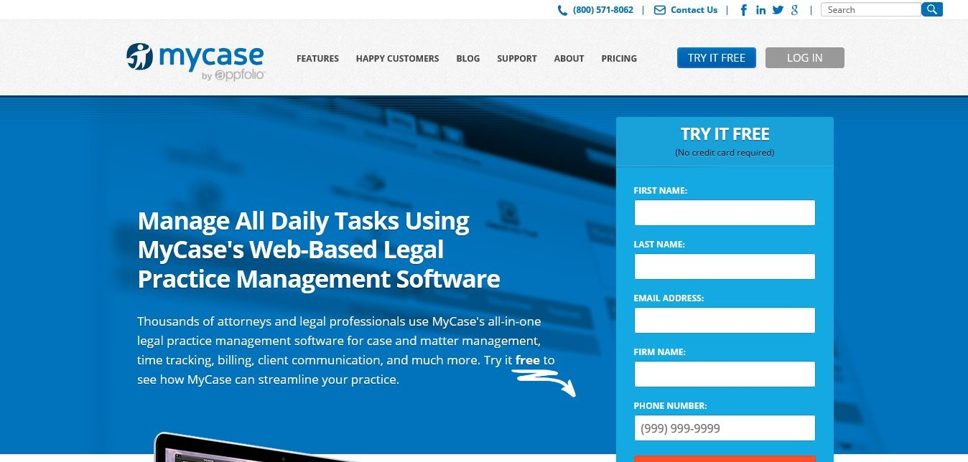

Figure 2.1: MyCase Web system

Also, this system is for all law firms (General platform and not customizable) and documents are to be hosted to their servers. The Law Firm Information Management System gives Firms a software at which they are able to customize to meet their needs.

### 2.2.2 Law Firm Systems

A general purpose Law Firm system which allows anyone to create their account and manage their profiles within the system as Law firms even if they are not.

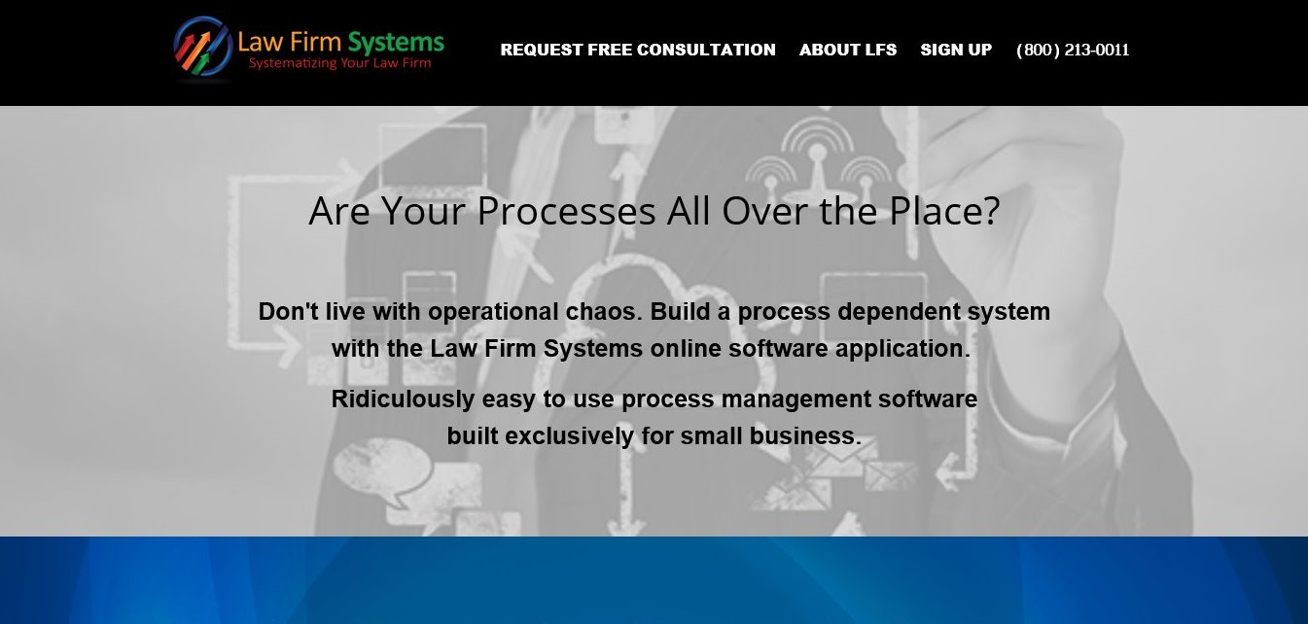

Figure 2.2: Law Firm Systems

**Weakness**

Just like MyCase, the Law Firm Systems does not guarantee access to customization in accordance to Firms’ requirements. Also it does not document Case proceeding and track number of events in a defined calendar UI.

### 2.2.3 FindLaw

A general purpose system in USA which include Law Firm operations with number of jobs related to Law.

**Weakness**

It includes a blog section on their website which were not the case during requirement elicitations with Tanzania law Firms. The FindLaw is based with online marketing of Legal services which is not the case with Tanganyika Law Society (TLS) where Legal services marketing is considered as bad law practices.

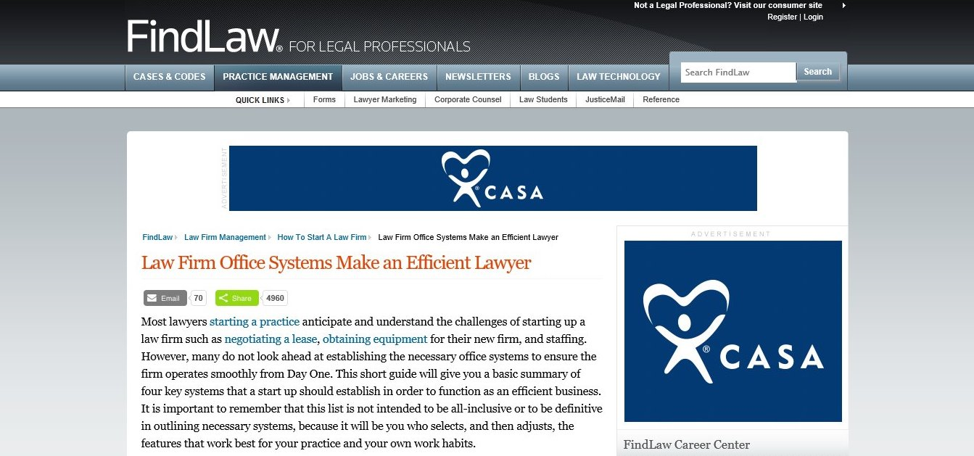

Figure 2.3: FindLaw Web System

### 2.2.4 Intuit Quickbooks

It is a Firm management software which has specialized in Accounting management in Law firms. It tracks retainers, trust and expenses, processes invoice for legal fees and reimbursements. It further organizes financials in a central location. In summary the software is only based with Accounting processes.



Figure 2.4: Intuit Quickbooks Web System

**Weakness**

This system is more of financial records in the Law Firm. In Law Firm Information System this is subsystem in it. Financial records marks one of most important functionalities of the Law Firm Information Management System.

There are more of other functionalities to include, most important of them is Case and Client details management which extends to management of Lawyers professions and qualification.

## 2.3 Problem Conclusion

Existing problems proves a serious need of the Law Firm Information Management System to facilitate daily operation in Legal practices governed by Law Firms. Digital innovation proves to be the most popular and effective solution to addressing challenges encountered and which in one way or the other leads to inefficient Legal operations.

# CHAPTER THREE:

# REQUIREMENTS ELICITATION AND SYSTEM ANALYSIS

## 3.1 Introduction to Requirement Elicitation

This chapter describes the enterprise, software system functional and non-functional requirements for Law Firm Information Management System that is responsible for digitizing Law Firm operations. The system is also responsible of enhancing relationship between Lawyers and Clients.

Requirement elicitation is the practice of collecting the requirements of a system from users, customers and other stakeholders. The practice is also sometimes referred to as “requirement gathering”. Before the requirements are analyzed and modeled, they must be gathered first through elicitation process (Raghavan, 2016).

Requirements engineering is a key problem area in the development of complex, software-intensive systems (Brooks, April 1987)

*The hardest single part of building a software system is deciding what to build.*

*...No other part of the work so cripples the resulting system if done wrong. No other part is more difficult to rectify later.*

System analysis is a problem technique that decomposes a system into its component pieces for the purpose of the studying how well those component parts work and interact to accomplish their purpose. There are mainly two phases involved in System analysis, namely feasibility study which is used to check whether the system can be implemented and Requirement specification which is used to find out what the system will be able to do. Some of the technique that can be used to accomplish this task are interview, literature review, group discussions and observation.

1. Feasibility Study

This analyses and evaluate the proposed system to determine if it is technically feasible, feasible within the estimated cost and if it will be profitable.

Feasibility studies are almost always conducted where large sums are at stake, sometimes feasibility study called feasibility analysis (Feasibility Study, 2017).

Also feasibility study is used to determine if the system should get the go-ahead, if the system is proceeding, the feasibility study will produce a project plan and budget estimates for the future stages of development.

Feasibility study is composed of three (3) main areas which are Economical, operational and Technical Feasibility Study.

* Economic Feasibility

The bottom line in many projects is economic feasibility. During the early phases of the project, economic feasibility analyses amounts to little more than judging whether the possible benefits of solving the problem are worthwhile. As soon as specific requirements and solutions have been identified, the analyst can weigh the costs and benefits of each alternative. This is called a cost-benefit analysis.

* Operational Feasibility

This is the measure of how effective the solution of problems will work in the organization. It seeks to answer the question “is it worth solving?” it is also a measure of how people feel about a new system.

Also it is related to human organizational aspects, the point to be considered here is what changes will be brought with the system? what new skills will be required, do the existing staff members have these skills and can they be trained?

* Technical Feasibility

This is concerned with specifying the equipment and the computer system that will satisfy and support the proposed user requirements. Here we need to consider the configuration of the system which tells the analyst how many work stations are required, how the units are interconnected so that they can operate and communicate smoothly. This is the measure of the practicality of a specific technical solution and the availability of technical resources and expertise.

## 3.2 Elicitation and classification of requirement

The purpose of this chapter is to define the requirements gathering process used to elicit requirements from the system’s stakeholders, to define the overall vision and goals of this new product, and to list those functional and non-functional requirements that are essential to the success of this system.The requirements included in this chapter are categorized in two groups namely, User requirements and System requirements;

### 3.2.1 User requirements

These are the requirement that the system is expected to perform to meet the users’ expectation. These requirements include functions that user wants the system to perform and how the system is going to be and the constraints on respected services to be offered by the system. These requirements can be grouped into three categories;

1. Function requirements
2. Non Functional requirements, and
3. Domain requirements

The system defines three levels of users who are responsible in managing and controlling Firms’ operation, the levels are derived from requirement specification. These users are:-

1. **Technical administrator**

This user is credited the highest level in the system including the server side operation. User can manipulate the Database without the need to access the system from the front end interface. This user is responsible of managing all technical issues of the system. He does not necessarily need to have User account to log in from the front end as he will be operating from the server.

1. **Firms’ Manager**

This is highest level of users in the Firm, granted access to all functionalities of the system and users in this level are responsible of managing Lawyers, Cases and Clients in the system. They are responsible of registering Lawyers and Clients with their respective Cases.

1. **Lawyers**

This is the lowest level of user defined in the system with limited access to functionalities. The Lawyer can only Register Clients and their Cases but cannot register or edit details of his fellow Lawyers for except his profile.

**3.2.1.0 Functional requirements**

Functional requirements deal with the behavior of the system basing on how tasks will be captured and produce beneficial output that is desired by stake holders. Behavior of the System may be expressed as services, tasks or functions the system is required to make sure it performs all tasks as it is designed to do. Functional requirements are useful study in development of the system that make easy to distinguish the system from competitors’ products and from variants and features that may be additional functionality, or differ from the basic functionality along some quality attribute (such as performance or memory utilization).

Thus, functional requirements in this System are: -

* The system registers Lawyers, Clients and their Cases and provides their list as it may be required.
* The system tracks Case proceedings as reported from the Court in each proceeding date, and further it provides a document containing the proceeding history of each individual Case.
* The system provides access for users to view their profiles and edit as it may be required.
* The system authenticates users and grant access to them according to their defined roles, Different roles have got different access to system functionalities.
* The system validates user inputs to avoid security vulnerabilities.
* The system processes case proceedings and print it in PDF whenever required.
* System shall ask for password confirmation when registering a System use at first time.
* The system provides general statistical figure about the firm, i.e Number of Cases attended, number of Lawyers and Clients registered and also it indicates number of pending and complete cases.
* The system allows Firms’ Manager to manage and manipulate users’ information

**3.2.1.1 Non Functional Requirement**

These are Constraints on the service or functions offered by the system such as constraints on the development process, standards, reliability, response time and storage requirements. The following are the systems’ non-functional requirements:

**Usability**

The system is user friendly, that, it is easy for user to interact. Also the system is designed in such a way that it is able to accommodate changes. The system is also responsive with different device and browser platforms in market.

**User interface and Human factors**

Considering the fact that the system is to be used with both literate and illiterate computer users, hence it is designed with very interactive interface to enhance all types of users. The system is composed by responsive interfaces that enable users with different devices such as computers, tablets and mobile phones to have good interface without losing any details from the system.

**Robustness (Error Handling and Extreme condition)**

The system handles errors encountered during runtime. Errors arising from users and from the system. Errors that encountered from users’ wrong operations are handled by the appropriate exception handling mechanism and incase of database failure, system backup will be used to resume to normal system’s operations.

**Security**

The Law Firm Information Management System uses Authentication as one of security measure so that no unauthorized user should be able to login into the system. Only users having a password and username are able to view and manage system’s operations.

Also the system has defined access control with user levels, just to ensure that there is no any low level user is able to access high level users’ functionalities. For instance, functionalities accessed by Firms’ Manager should be different from that accessed by our Clients.

**Availability**

The Law Firm Information Management System is developed and designed as a Web system which is to operate in Networking (Internet) environment. This is to ensure that the System is available whenever user requests access to services from Systems’ address.

**Speed**

The system is very fast in loading data and being responsive to user’s requests in order to draw user’s attention when interacting the system.

The Law Firm Information Management System deploys number of measures to ensure that it is fast and efficiency, these measures includes: -

1. **Query Optimization**

The system has considered the cheapest execution plan among existing option in Query processing. Queries with cheapest execution plan uses considerable little computing resources (Memory and Storage) and executes fast.

1. **Scripting Languages**

The system is integrated with JavaScript which is powerful language in manipulating HTML scripts and control the behavior of web pages. Using JavaScript, the system was able to reduce number of pages (by creating popup pages) which reduces the loading time during execution and system operations.

**User friendliness**

The system is simply adaptive to users, well structured, simple to use to make user using the system comfortably. It is contained with welcoming web pages with functionalities which are self-explanatory to make users surf the system easily. On landing page, the system provides users with all directives to navigate into any page of the system and good enough is that the system provides simple stats on the operation of the Law firm which uses the System.

**3.2.1.2 Domain Requirements**

These are the requirements of the system that are derived from application domain. They refer to characteristics and constraints of the domain and sometimes may be from function and nonfunctional requirements (Sommerville, 2017). The following are the domain requirements for Law Firm Information Management System;

* **Language**

The system is deployed in English since English language has been the language commonly used by many systems and widely used by many people. Also most of their operation are now operating in English Language.

Also by considering that Law Firms/Law practices are mostly documented in English, developing a system in English Language improves its compatibility with other documents and files to be stored in the system.

* **Interoperability**

The system is able to work together with other system available concerning Legal operations. For example, Case management in a firm could be embedded with Court management system

### 3.2.2 System Requirements

These are the requirements that should be met for the system to operate since they may be accessories, supporting application or infrastructures that are required for the system to be adopted. The following are the system requirements for Law Firm Information Management System;

* Network – To enable remote access of the system and improve availability aspects.
* Web browser – Hosting Platform for handling user interfaces for the system, inputs and outputs of the system from and to user respectively.
* Web server – For processing and responding to user’s requests
* Database server – To host the database and its contained data

### 3.2.3 Use Case diagram

Use case describes sequence of events for the users who use system functionality to complete various processes. Use cases are described in terms of interactions between users of the system and the system itself.

Use case is used in order to demonstrate the system’s behavior and how the user will interact with the system. Here are the use cases of Law Firm Information Management System which includes only two (2) actors, Firm Managers and Lawyers.



Figure 4.0: A Use Case Diagram

Table 3.2.3: Use Cases Description

|  |  |
| --- | --- |
| **Actor** | **Descriptions** |
| Administrator | * Overall operation of the system including technical support |
| Firm’s Manager | * Register Lawyer * Update Lawyer details * Suspend Lawyer * Add Cases * Register Client * Update Case Details * Update Client Details * Add Case proceedings * Assign Cases to Lawyer * Manage schedule |
| Ordinary Lawyer | * Add Cases * Register Client * Update Case Details * Update Client Details * Add Case proceedings * Assign Cases to Lawyer * Manage schedule |

# CHAPTER FOUR

# SYSTEM DESIGN

This chapter describes the system design and architectural design of the system including Solution envisioning, adopted architectural and design orientation of the system.

## 4.1 Introduction to system design

System design is the practice of defining the elements of a system such as the architecture, modules and components, the different interfaces and the information that goes through that system. It is meant to fulfill specific needs and requirements of a business through the engineering of a coherent and well-running system.

Systems design involves systematic tactic to the design of a system. It may take a bottom-up or top-down approach, but either way the process is systematic wherein it takes into account all related variables of the system that needs to be created from the architecture, to the required hardware and software, right down to the information and how it travels and transforms throughout the system. Systems design then overlaps with systems analysis, engineering and systems architecture.

There three kinds of design that based on requirement elicitation, which are: -

* **Architectural design** - describes the structure, behavior, and more views of the system design and analysis.
* **Logical design** – is the representation of the information flow diagrams, inputs and outputs of the system. It involves Unified Modeling Language (UML) diagrams such as class diagrams, activity diagram, use case diagram, sequential diagram, communication diagram e.t.c.
* **Physical design** – is the actual input and output processes of the system. It is explained in terms of how data is input into a system, how it is verified or authenticated, how it is processed, and how it is displayed.

## 4.2 System design implementation

This part describes the systems’ methodological view and Design, including database and interface design. This part will also describe the logical flow using UML Diagrams, Activity Diagram, Sequential Diagram and the ER design.

### 4.2.1 Methodological review

Software development process requires the undertaking group ought to embrace pre-characterized improvement model with a specific end goal to accomplish an objective in core interest. All product procedure models can oblige the bland system exercises, yet each applies an alternate accentuation to these exercises and characterizes a procedure stream that conjures every structure action. In my project XP and Agile methodologies have being used in development procedures.

## 4.3 Database design

The designing of the database reflect the functional requirements collected in requirement elicitation. Thus, the system requires various entities such as Firms for Case documentation.

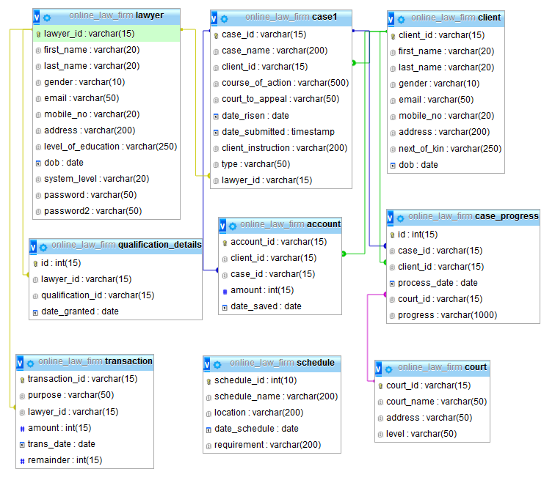

Figure 4.1: The structure of ER Diagram

## 4.4 User interface Design

The designing of user interface comprises of the flow activities in where the user interacts with the system. Thus, the designing of user interface must be clear and simple to make sure user does not get difficulties on how to interact with the system. The following are sample interfaces adapted in system design,

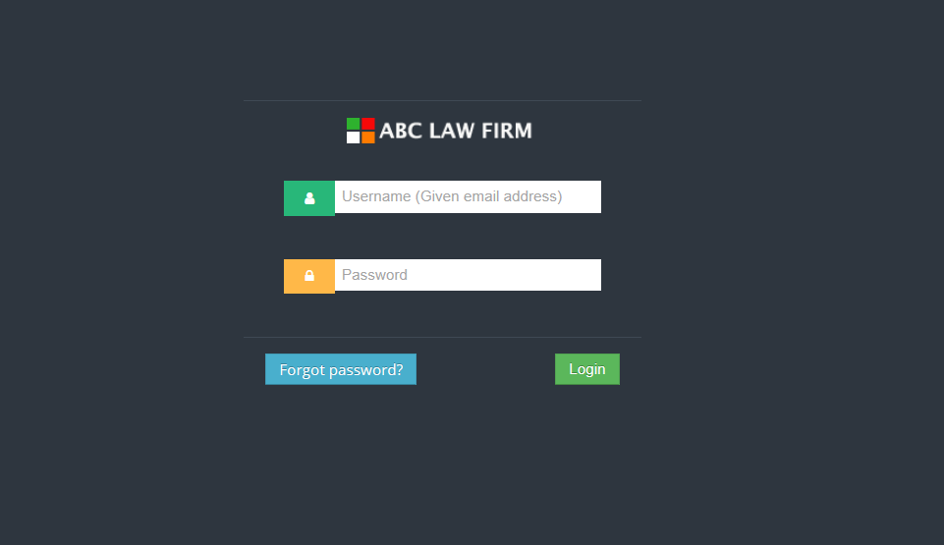

Figure 4.2: A front interface design of the System

### 4.4.1 Activity diagram

This is a graphical illustration of workflows of stepwise activities and actions with support for choice, iteration and concurrent. It is intended to model both computational and organizational processes (i.e. workflows). Activity diagrams show the overall flow of control.

Activity diagram used for: -

* Describing a business process or a flow of work between users and the system.
* Describing the steps performed in a use case.
* Describing a method, function or operation in software or system.

In activity diagram: -

* **Rectangles** - represent actions
* **Diamonds** - represent decisions
* **Bars** - represent the start (split) or end (join) of concurrent activities
* **Black circle** - represents the start (initial state) of the workflow
* **Encircled black circle** - represents the end (ending state).
* **Parallelogram** – represent inputs and outputs of the system.



Figure 4.3: Activity Diagram

The activity diagram above describes the flow of activities throughout the system, where after user’s attempt to login in the system, the system first authenticates the user, if wrong credentials were provided the system turns back to the Login page and if success, the system directs users to level access defined, all users should log out from the system after performing their activities.

### 4.4.2 Sequence diagram

Is an interaction diagram that shows how processes operate with one another and at which order. It depicts the objects and classes involved in the scenario and the sequence of messages exchanged between the objects needed to carry out the functionality of the scenario. A sequence diagram shows object interactions arranged in time sequence.

In sequential diagram: -

* **Classes (Actors)** - represented by columns
* **Messages** - written with horizontal arrows with the message name written above them, display interaction.
* **Solid arrow heads** represent synchronous calls,
* **Open arrow heads** represent asynchronous messages,
* **Dashed lines** represent reply messages.



Figure 4.4: A Login Sequential Diagram Design

# CHAPTER FIVE

# SYSTEM IMPLEMENTATION

## 5.0 Introduction

This chapter describes the implementation and evaluation processes towards the system development. In terms of implementation, the development environment, tools, development platform, database used and levels of system users are also discussed. The designs are translated into code. Computer programs are written using a conventional programming language or an application generator. Programming tools like compilers, interpreter’s debuggers are used to generate the code. Different high level programming languages like C, C++, Pascal, java even visual basic are used for coding. With respect to the type of application, the right programming language is chosen.

## 5.1 Introduction to implementation

Implementation is a realization of a technical specification or algorithm as a program, software component, or other computer system through computer programming and deployment. The implementation of the system requires various tool upon completion and testing. During implementation of the project different scenarios are made into assumption in order to meet system objective

### 5.1.1 System assumption: -

1. System will have a database for storing auto generated tokens for approving payments.
2. Lawyers will be able to download Case proceedings after being approved by firms’ manager.

|  |  |
| --- | --- |
| **Hardware** | **Description** |
| Processor | Intel Centrino 1.6 Ghz Processor or higher or other equivalent processors |
| Memory | At least 512 MB  Recommended: 1GB or more |
| Hard Disk Drive (HDD) | At least 250GB (Does not affect system performance) |
| Others | Internet access |

Table 5.1.1(a): Hardware requirements

Table 5.1.1(b): Software requirements

|  |  |
| --- | --- |
| **Software** | **Description** |
| Operating System | At least Microsoft Windows 7 |
| Web Server | At least Apache 2.2.6 |
| Relational Database Management System | At least MySQL 5.0.45 |
| Internet Browser | Microsoft Edge or Google Chrome or others |
| Programming languages | JSP and SQL |
| Web design and Development tool | Netbeans, JDK, Xampp |
| Graphical User Interface (GUI) | Bootstrap |
| Image Editor | Adobe Photoshop and Illustrator |

## 5.2 Development Tools

Refers to different tools used in development of the System upon completion and testing.

* + 1. **JSP**

Java Server Pages (JSP) is a server-side programming technology that enables the creation of dynamic, platform-independent method for building Web-based applications. JSP have access to the entire family of Java APIs, including the JDBC API to access enterprise databases. JSP was chosen as the server-side scripting dialect since it is used to create web application just like Servlet technology. It can be thought of as an extension to servlet because it provides more functionality than servlet such as expression language, jstl etc.

* + 1. **Bootstrap**

Bootstrap is a pre-defined CSS platform for developing responsive web designs. It is customizable platform which enables creations of own classes depending on the preferences apart from what have already pre-defined by bootstrap itself. Bootstrap contains good interfaces that are responsive to any device that access the web developed design.

* + 1. **JavaScript**

Java Script is the customer side scripting dialect utilized amid the improvement stage. In specific circumstances, JavaScript must be utilized rather than PHP. One such occurrence incorporates showing pop-up windows to ready users of blunders in information entered amid approval of info or conceivable loss of information when an erase operation is executed.

* + 1. **HTML**

HTML, acronym for HyperText Markup Language, is a markup language used to describe the formatting of text in a document. It is useful in the sense that it allows text to be structured according to its purpose, namely as a heading, paragraph and so on. This is accomplished by writing the HTML in ‘tags’ that describes to the web browser how the text is to be displayed. A scripting language such as PHP and JavaScript can be easily embedded in HTML to enhance the functionality of HTML.

* + 1. **CSS**

Is a style sheet language used for describing the presentation of a document written in a markup language Along with HTML and JavaScript. CSS is a basis technology used by most system to create visually engaging pages, user interfaces for web applications, and user interfaces for many mobile and desktop applications. CSS is designed primarily to enable the separation of document content from document presentation, including aspects such as the layout, colors, and fonts.

## 5.3 Development Platform

The latest Windows 10 was chosen since it contains a lot of security features cannot be found in any other Windows series in the market. Windows 10 receives latest updates including Java compatibility updates. Windows 10 further supports a lot of latest tools and features and some of them have being included in its features.

## 5.4 Database Management System

MySQL is a relational database management system (also known as an SQL Database Server) which is widely used around the globe since it is being open-sourced. Most SQL servers provide reliability but not ease of use unlike MySQL. When using JSP to develop a system, only supports a MySQL database connection as both JSP and MySQL are strongly connected using JDBC Drivers.

## Functionalities and services implementation

Functionalities and services implementation of the system are categorized based on role and impact of user provided by system. Thus, functionalities and services implementation are: -

**5.5.1 Administrator**

The person responsible in managing and monitoring the system. Thus, the system designed to granting ADMIN towards: -

* Access to all defined functionalities in the System,
* Providing technical support to users, this includes access to server side for user support.

**5.5.2 Manager**

This is a Registered Lawyer given privilege to manage other Lawyers who are the users of the system. In Law Firm environment this may be Firm’s Manager, Secretary on the mandate of Manager or Firm’s partners.

* Registration of Lawyers, Client and Cases in respect to updating their details
* Management of schedules
* Adding and editing case progress.

**5.5.3 Lawyer**

This is an ordinary Lawyer who may be employed or working as an intern in the Firm. The Lawyer has less privilege comparing to Firm Manager. He has given the following privileges: -

* Registration of Clients, Cases and updating their details,
* Management of schedules
* Adding and editing their case progresses

**5.6 Implementation of security services**

The system must be secured, such that an attacker cannot view or modify any data in the system. User is not allowed to access system data unless authenticated. The access permissions for system data may only be changed by the administrator. And all external communications between the system’s data server and users are encrypted using SHA1 hash function algorithms.

This application has implemented basic security behaviors:

* **Authentication**: All users of the system have to login using username (in this case its email address) and a password (which may be default password or defined password)
* **Authorization**: According to their profile and user levels, users must be granted or not granted access to perform some specific functions (access records, making updates, etc.)
* **Confidentiality**: Sensitive data are encrypted (such as password encrypted by using **SHA1** algorithm).
* **Data integrity**: Data sent across the network cannot be modified by a tier
* **Availability**: The availability of the system is a key requirement; the system is accessible at any time a user may need to perform actions.

## Back end and database implementation

this chapter discusses about the backend implementations with respect Database implementations. This will further include a brief introduction to Programming Languages used and Database management system used.

* + 1. **Database implementation**

Database system is the storage place of information in the system and where information is retrieved and data are inserted in different operations offered by system. The system contains eleven (11) tables which stores information about Users, Cases, Case Progress, Account information and financial management.

* + 1. **Back-end implementation**

The system is implemented using Java Server Pages (JSP), a back-end programming language which uses Java language in manipulation of databases (SQL Querying) and acts as bridge between the UI and backend. In some parts Javascript were used to improve DB manipulation and page simulations.

## Front end and User Interface implementation

The system interface is well designed to ensure users interact with the system using any platform. Each user in the system play their roles as defined during registration process. Each user MUST provide their authentication credentials (Email and Password) accordingly, the system directs users according to their roles and give privilege according to their level of access. The following show user interaction interfaces accordingly, start with HOME page: -

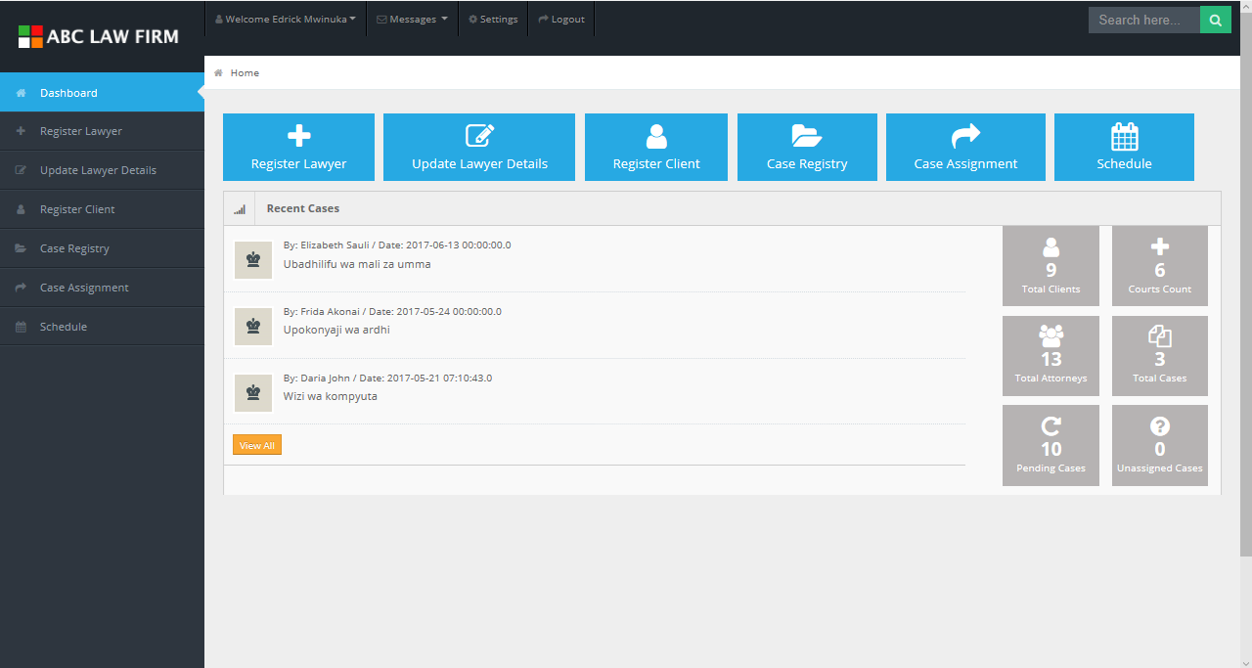

Figure 5.1: A front end interface design (Landing page after Login)

Home page gives a user very descriptive interface at which a Manager/Lawyer can view the very recently added cases but also the system has made it easier for managers to access quick stats like, number of Lawyers, Clients and Cases registered in the system but also it indicates number of pending Cases.

The Home page further gives a user access to all links to basic functionalities of the system. On the top bar, the system indicates user’s name with some profile settings.

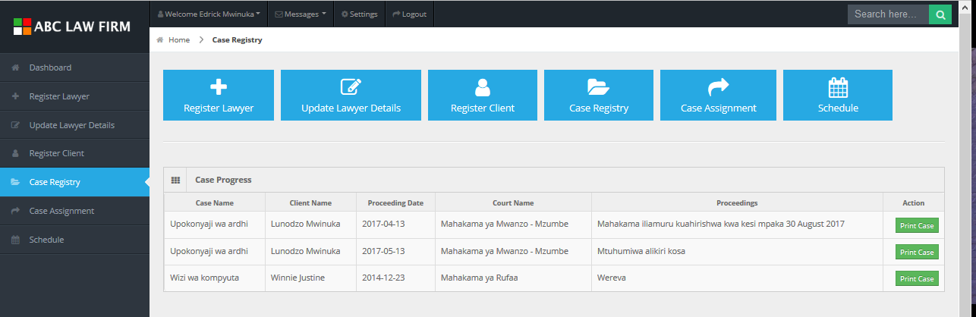

Figure 5.2: Case Progress

The most important feature of the system is Case management. The system gives access to users to add Case proceedings as the Case progresses at the Court and from the given interface user can print the case progress as shown below: -

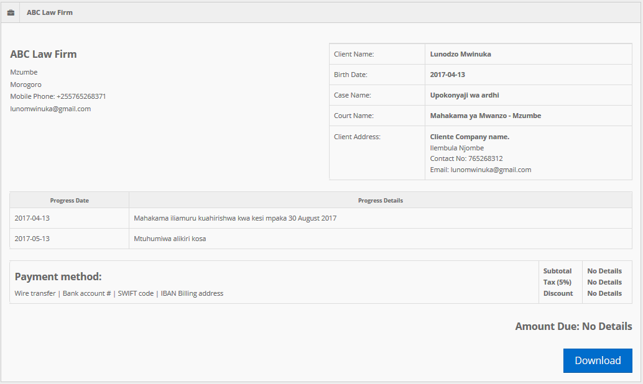

Figure 5.3: System's report

The document to print contains details of the firm and Clients, more importantly it contains details about Case and Court the Case is being carried on with respective Lawyer. The document further contains financial information of respective case.

## System testing and evaluation

The system testing was done throughout the development process in all phases to guarantee error free and fulfil system functionalities, all as planned. System testing was done starting with Database design by testing the validity of referential integrity and constraints defined in database tables. Virtual testing was conducted to ensure that the Database system reflects all the functional requirements of the system works efficiently. The System has to ensure security from validating users inputs and hence the system is built with form validation in each designed form.

The evaluation of the system was carried out so as to assess whether the system was meeting user requirements, also it was carried out in order to assess whether the new system was compatible with manual system present, also the system was tested to see how interactive the it is, with users. Finally, the evaluation intended to see whether the system development processes and the system developed fulfill the planed project objectives.

### 5.9.1 Unit Testing

Unit testing was carried out on individual modules of the system to ensure that they are fully functional units. It was done by examining each unit, for example checking validation of any user who login to the system if have already registered or not and pop a relevant message.

### 5.9.2 Integration testing

Integration testing was done after making all modules together to make a complete system. This aimed at ensuring that modules are compactible and they can be integrated to form a complete working system. For example, the system made impossible for Lawyer to manipulate information about their fellow Lawyers, this is made possible to only Managers of the Firm.

# CHAPTER SIX

# CONCLUSION AND RECOMMENDATIONS

## 6.0 Introduction

This chapter describes the objectives of the system described in earlier chapters, achievement of the system objectives, conclusion and recommendations of the system.

## 6.1 Achievement of research objectives

As discussed in the previous chapters the main problem (study area) that addressed was Case processing among Law Firms in Tanzania. The system will enable Lawyer to manage Case progress and Client details online and hence ensuring safeness of Case documents.

The objectives of the system have been well achieved as the major objective was to develop a Web based system that will enhance case processing among Law firms in Tanzania to improve efficiency and security of case details. The specific objective derived from the main objective were also achieved as system performs the following services: -

* 1. Solve the problem of managing sales of film produced by film companies
  2. Advertisement of movies and trailers for present movies and upcoming movies to create awareness to movies followers.
  3. Registering and managing companies, groups and individuals accounts to enable manage accounts and track their basic information from their uploads

## 6.2 Limitation/weakness of the system

* The system does not track financial details and also still does not provide a room for the Client to access their Cases online.

## 6.3 Future work

* The system should focus on providing better means of simplifying management of Firms in respect to Cases and client details,
* The system should focus on grabbing the market and being the leading online platform among Law Firms in Tanzania,
* The system should focus on extending its functionalities including building a mobile application to enhance system availability and accessibility,

## 6.4 Conclusion and Recommendations

The Law Firm Information Management System is a well performing and efficient system that could be of advantage to Law Firms in Tanzania by enhancing their daily operations. The system will simplify management of cases but also support decision making of Law firms by tracking the progress of firm’s operations. There must be no loss of case files or client details and further the system could reduce the paper works.

The system further gives a platform for Lawyers to provide a presentable profile by tracking all professional details and publications.

The system strength will be evaluated and users can point the weakness point of view of the system. In the long run, the system should be perfectly functioning.

Due to some weaknesses of the system discussed above, I recommend for further researches to improve the Law Firm Information Management System operations. Still there is a remarkable need for requirement elicitation considering the fact that, this project have been refereeing to only one law firm to collect information and develop system functionalities. It could be more effective having a distributed information collected from different stakeholders of the system across Tanzania with variety cultures and mode of operations.

# REFERENCES

Aitken. W (2007). "Use of Web in Tertiary Research and Education."Webology, 4(2), Article 42. Retrieved 13, April 2017 from. <http://www.webology.ir/2007/v4n2/a42.html>

Boehm, B. W. (1988). A Spiral Model of Software Development and Enhancement. Computer, 61-72.

Ezekia Gilliard (2015). Online Student Registration System (OSRS): Mzumbe University

Khosrow-Pour, M. (Ed.). (2002). Web-based instructional learning. Hershey, PA: IRM Press.

L. Naismith, (2007). Using text messaging to support administrative communication in higher education. Active Learning in Higher Education, Vol 8, 155-171.

M. C. Little, S. M. Wheater, D. B. Ingham, C. R. Snow, H. Whitfield and S. K. Shrivastava (n.d). The University Student Registration System: a Case Study in Building a High-Availability Distributed Application Using General Purpose Components. Newcastle University, England.

Praise Mwiruki (2014). The university mobile based fee processing system. A case of Mzumbe University main campus Morogoro: Mzumbe University

Strauss, Howard (2000). Tech Talk Event CNI Spring Task Force Meeting, March 27-28. Retrieved Wednesday 13, April 2016 from [www.cren.net/know/techtalk/events/portals.html](http://www.cren.net/know/techtalk/events/portals.html).